Final Visualization-

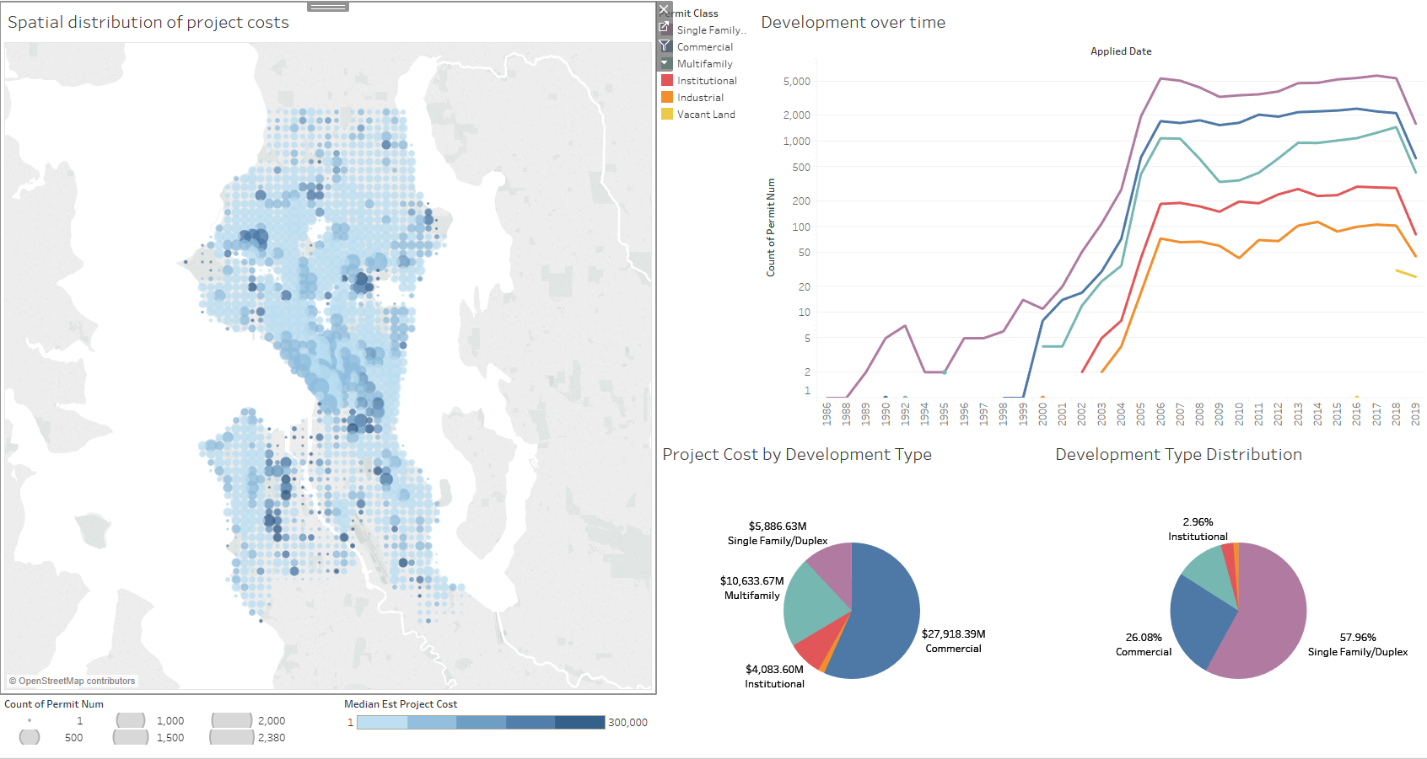

Figure 0- Interactive dashboard visualizing permit data for the Seattle housing market

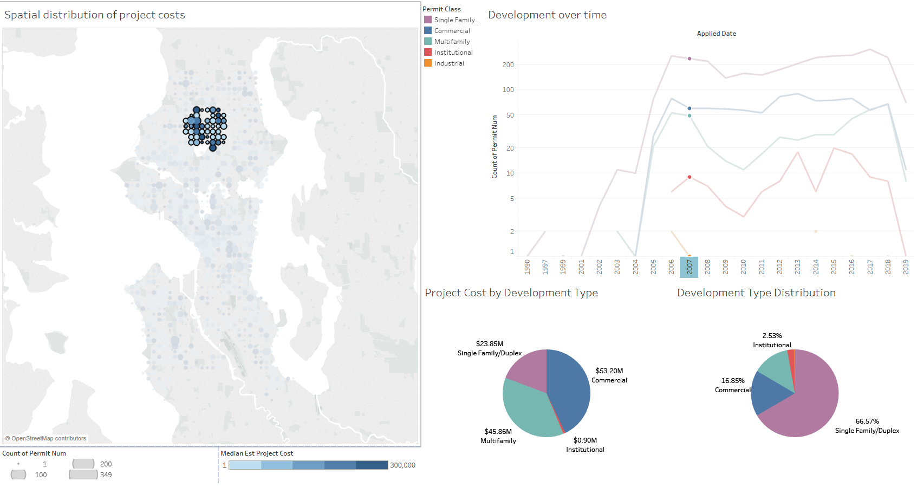

Figure 0.1- Visualization updating based after user filters on tempral and spatial fields in the dashboard

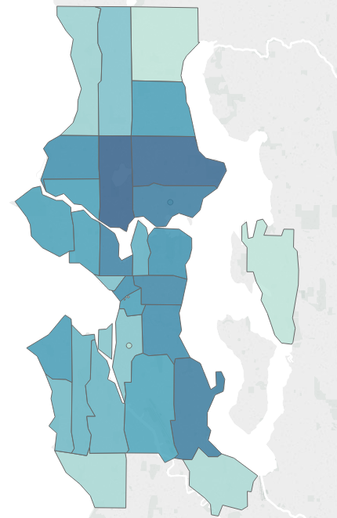

Question- How do permits vary spatially in Seattle?

Figure 1- Distribution of permit counts by zipcode

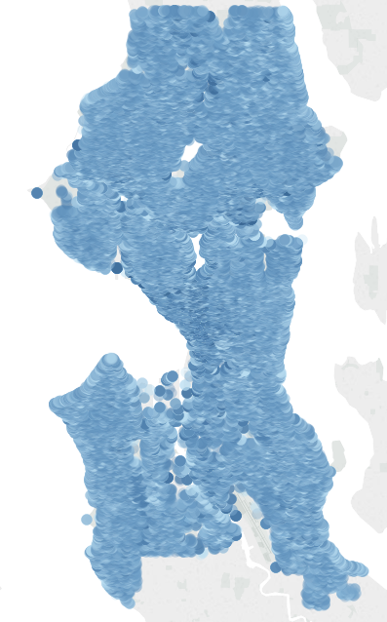

Question 2- Selecting a facet of the permit data- how does that vary spatially?

Figure 2- Plot of each permit’s estimated project cost

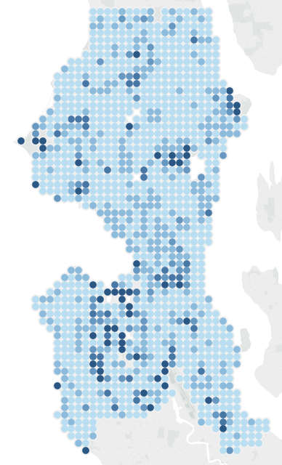

Question 3- Can I simplify my visualization to better reflect spatial trends?

Figure 3- Median estimated project cost binned by geo-coordinates

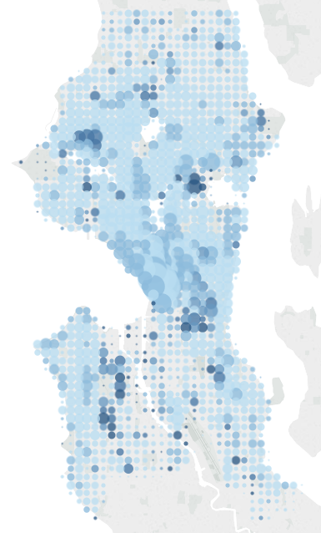

Question 4- How do the applications for permits vary in the above map?

Figure 4- Median estimated project cost and number of permits binned by geo-coordinates

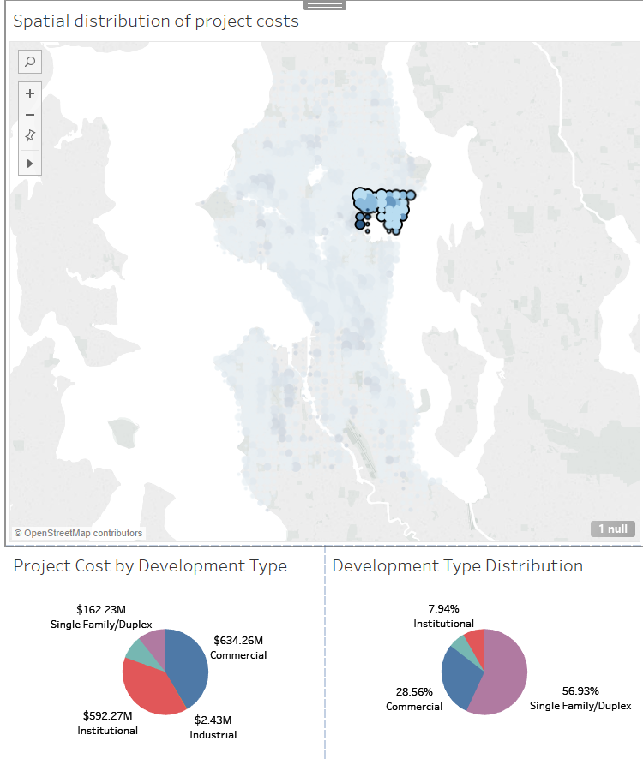

Question 5- Are there spatial trends amongst permits?

Figure 5- Proportions for the permit count and their total estimated cost for a subset of geo-coordinates.

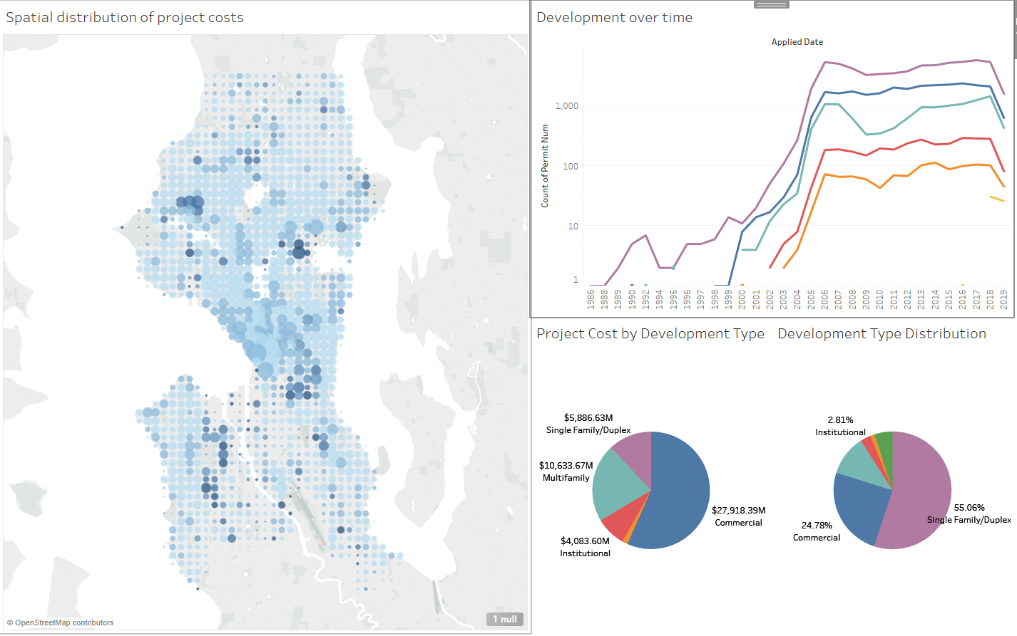

Question 6- Are there temporal trends for a given subset of spatial points?

Figure 6- Integration of a line chart visualizing temporal trends in permit applications